**Emmanuel Sankoh SCCJ/01438/2019**

**Haron Maruri SCCJ/01449/2019**

**Roy Uri SCCJ/01447/2019**

**Hannah Kihoro SCCJ/01436/2019**

**Benson Muthui SCCJ/01431/2019**

**James Muthii SCCJ/01448/2019**

**Flow Charts**

**Sign Up Flow Chart**

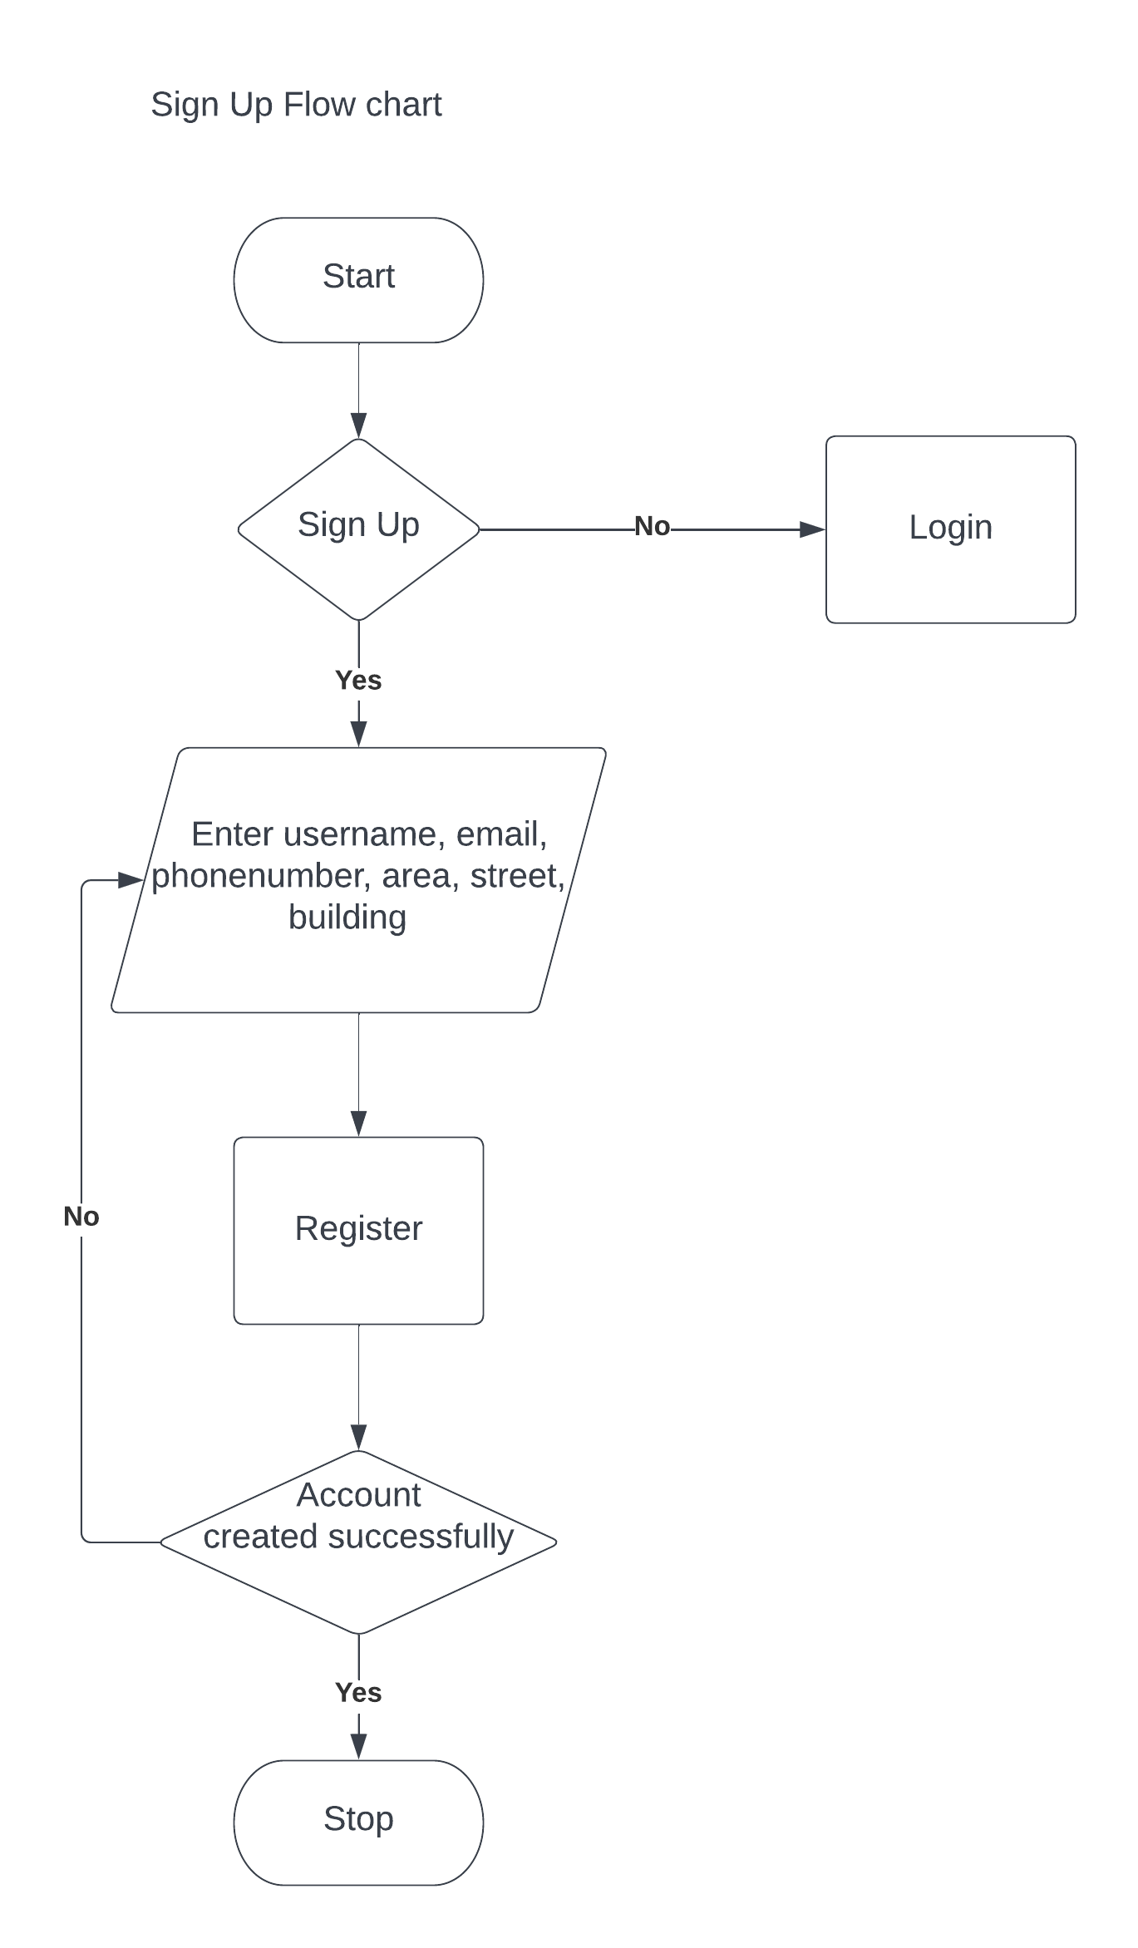

**Login Flow Chart**

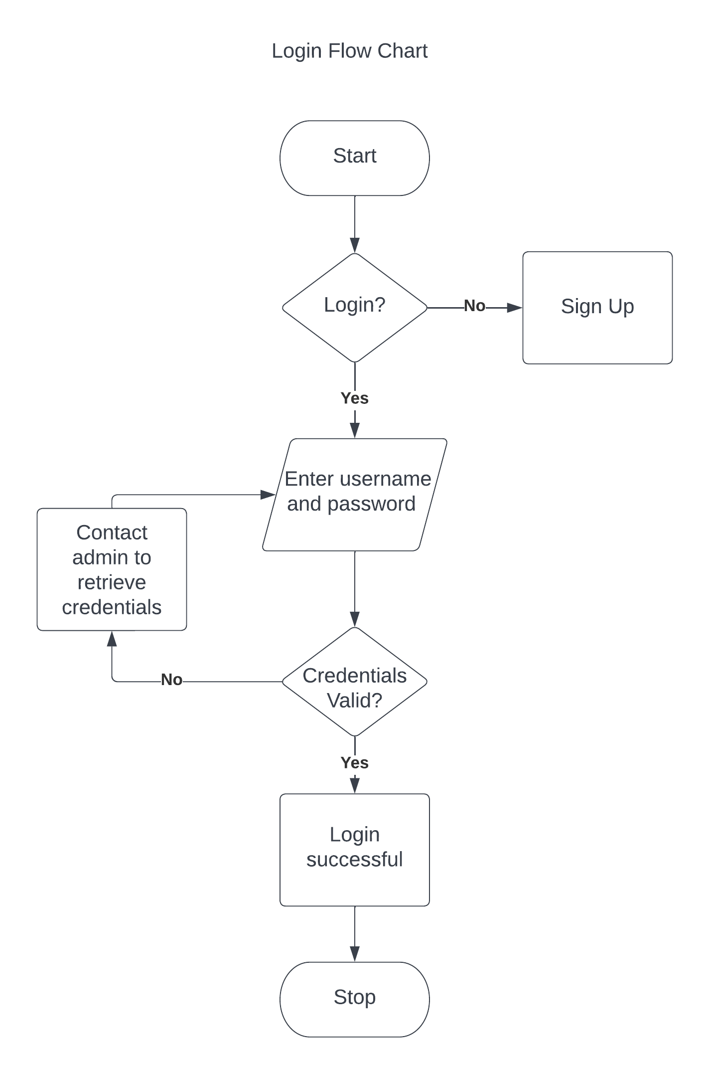

**Place Order Flow Chart**

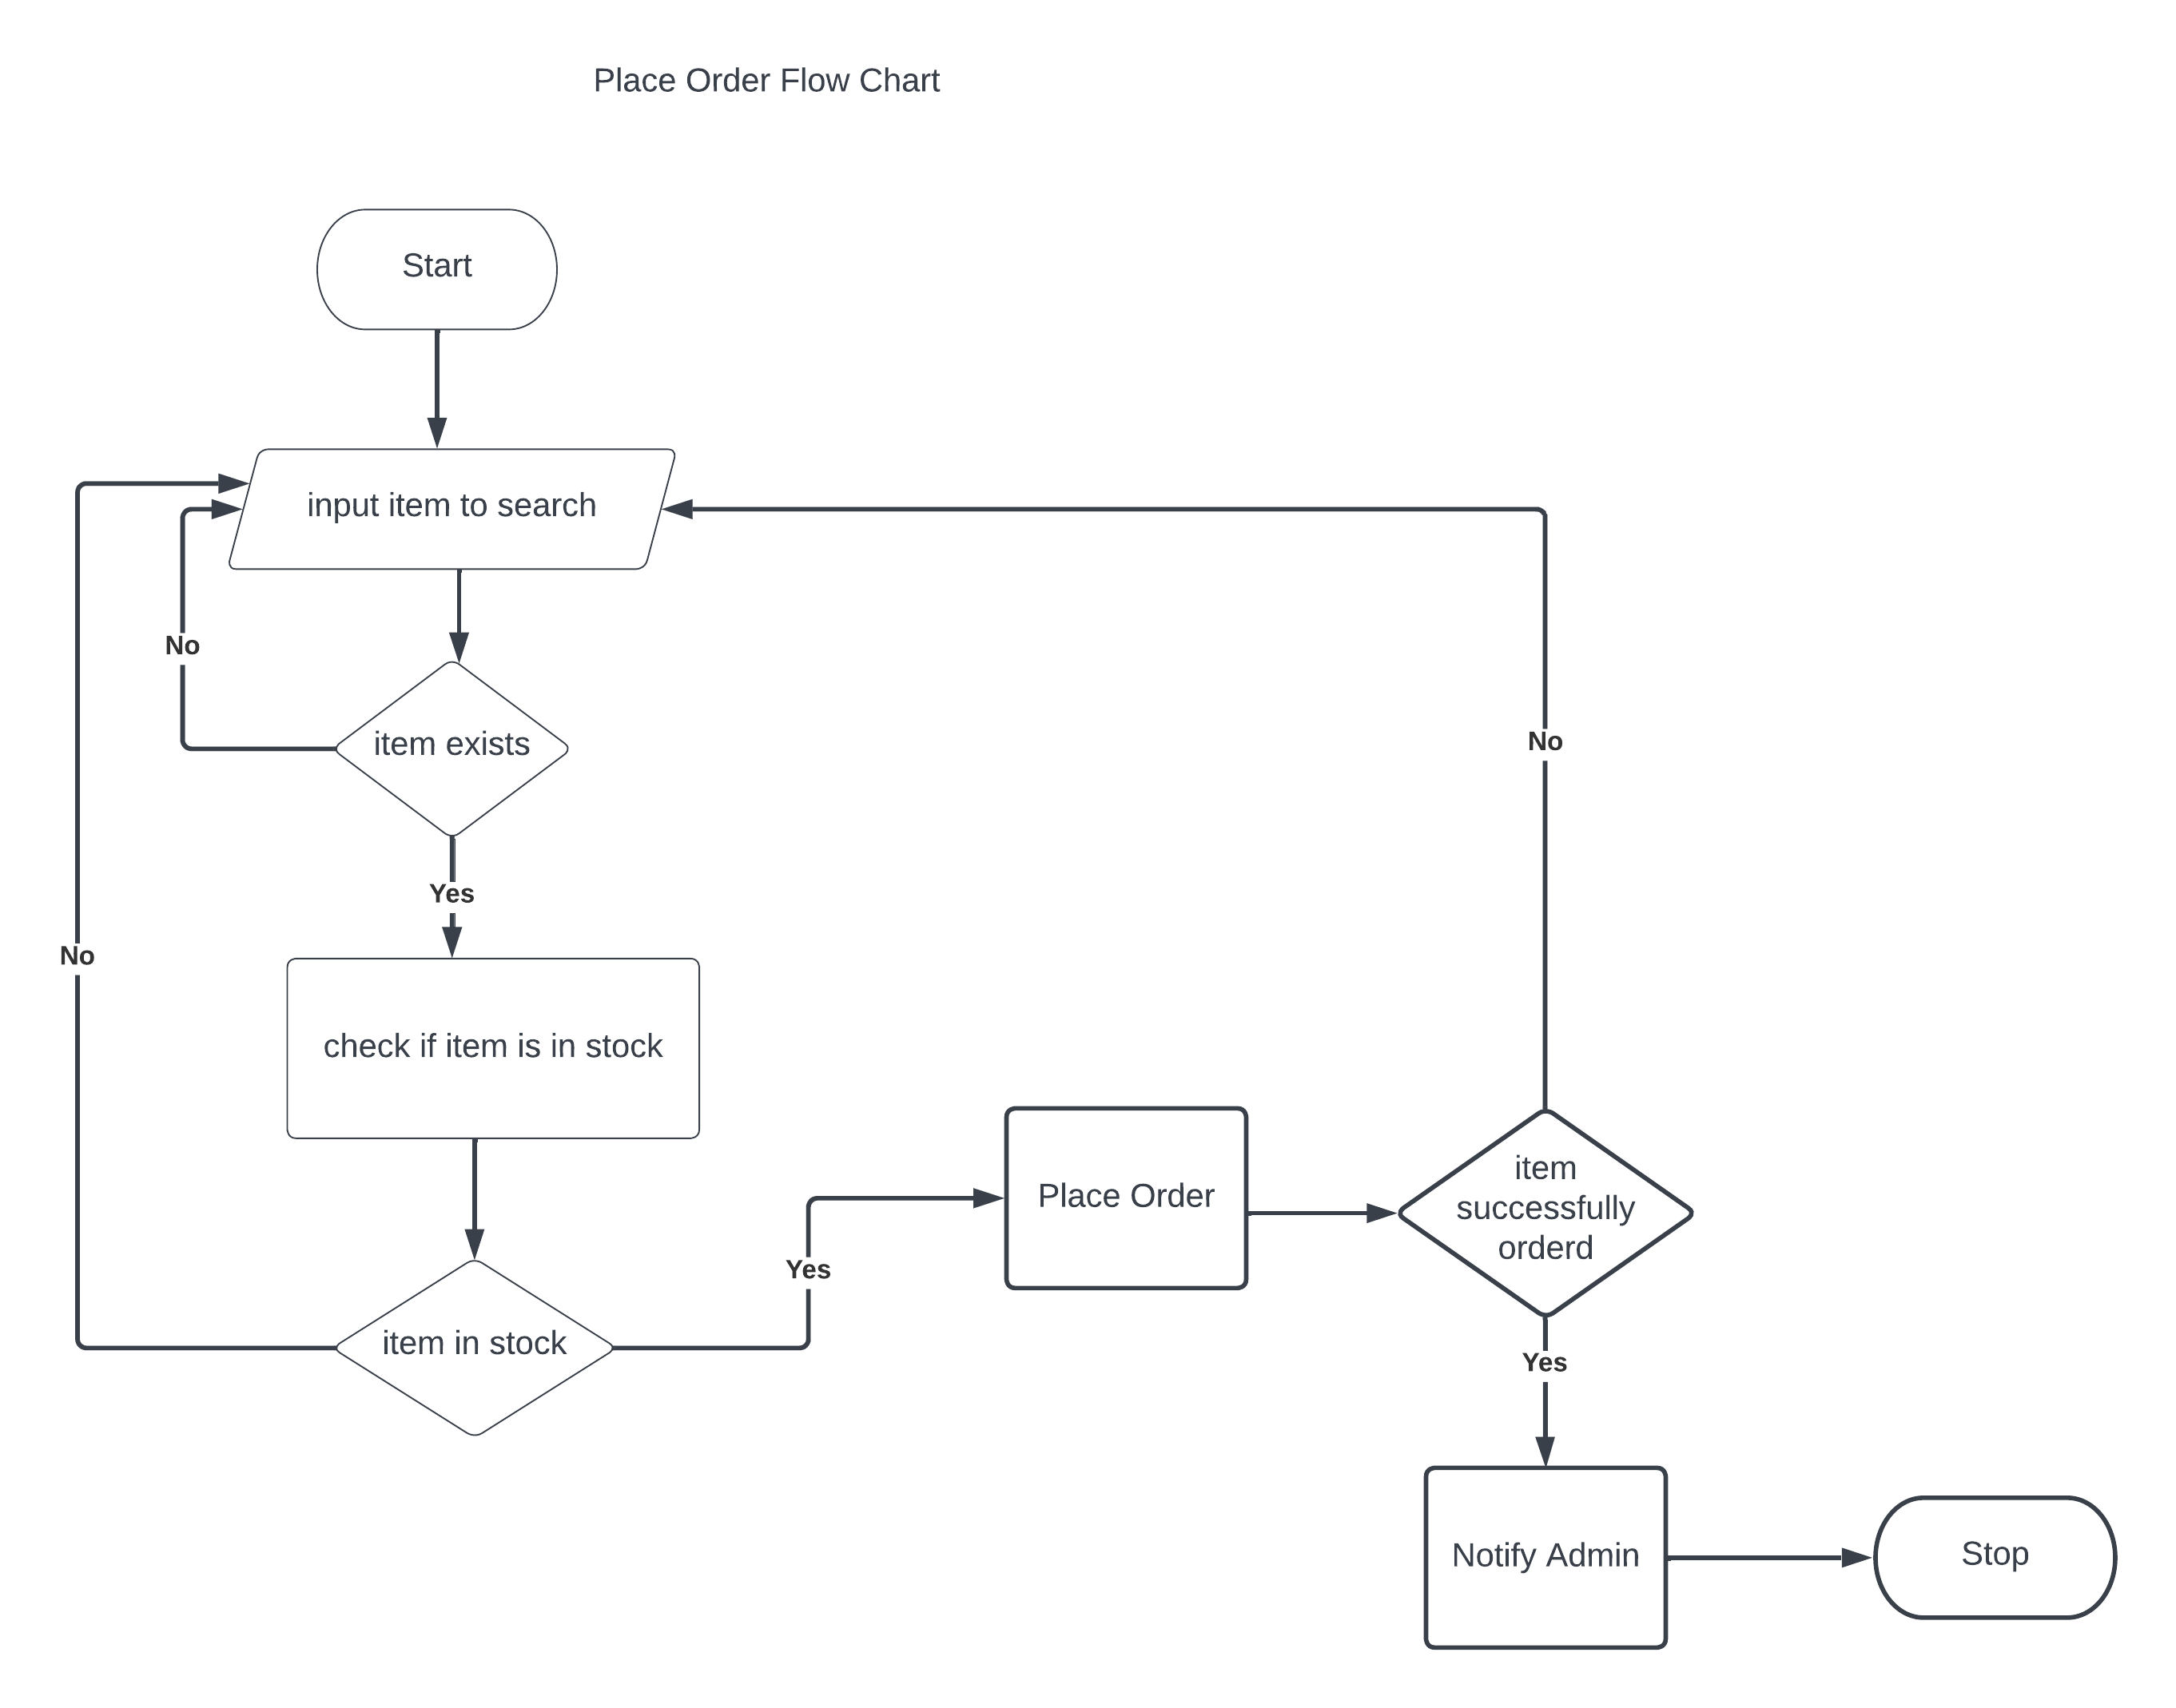

**Making Delivery**

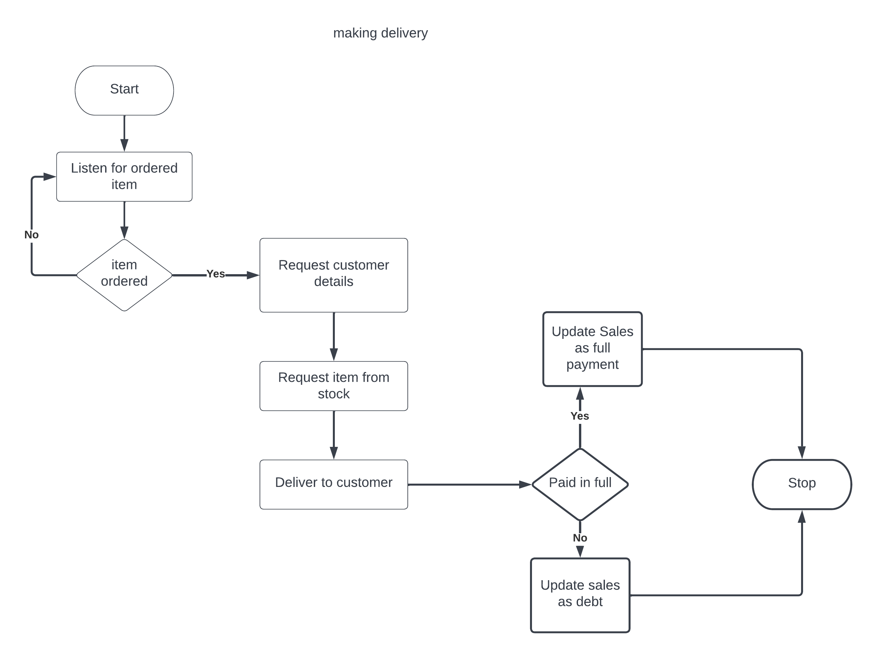

**Inventory**

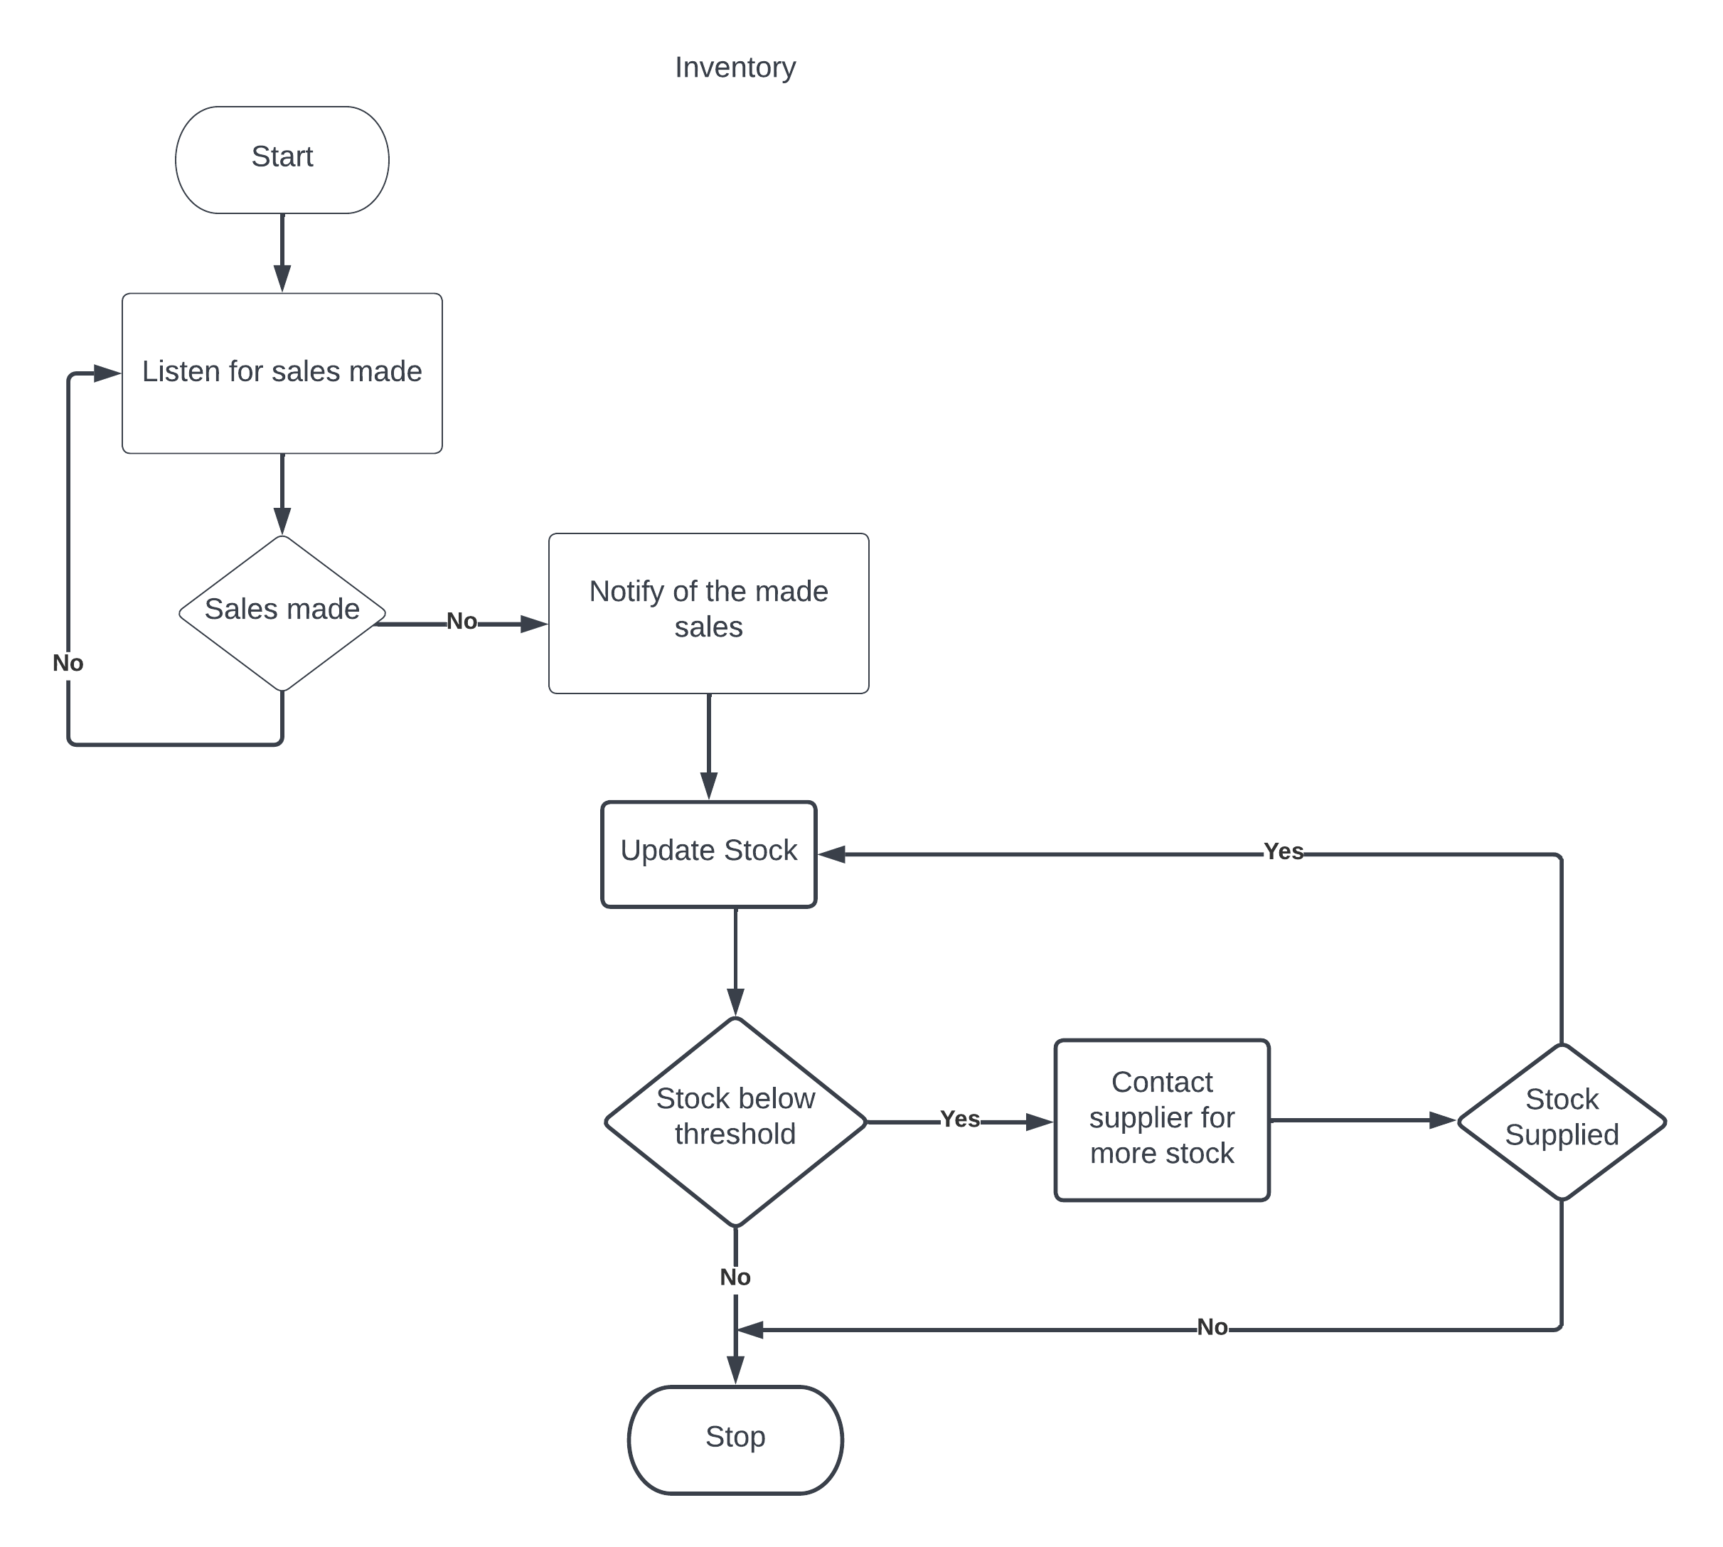

**Sales Management**

